CRM NERGY
Advanced Artificial Intelligence [ Login / Create Account ]
CRM Solutions Every Business Needs

Industries Using the CRM NERGY Software
CRM software is essential for various industries to manage customer relationships and enhance operational efficiency.

CRM NERGY “Make AI Your Bestie”
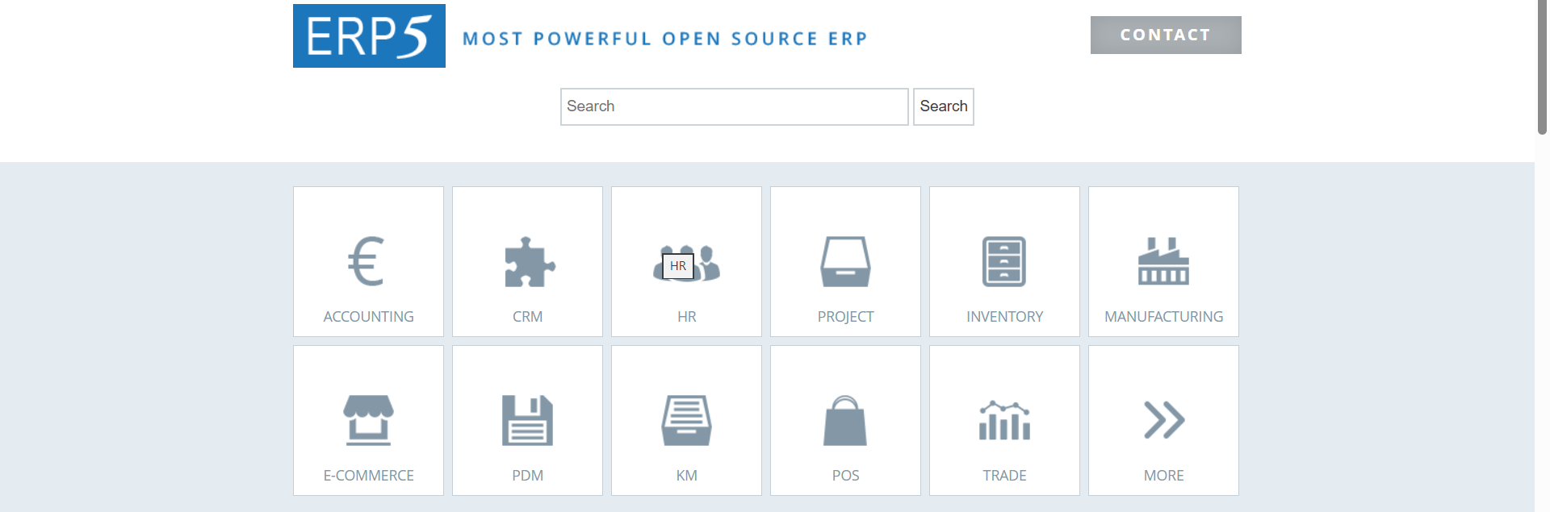

Some of the Industries that use the CRM nErgy Software

Branding and Customization
The CRM nErgy drag-and-drop feature in customizable CRM software greatly enhances usability and efficiency, enabling users to customize their systems according to their specific business processes without requiring any coding skills. This functionality is crucial for contemporary CRM solutions, rendering them more flexible and user-friendly.

“Make AI Your Bestie”
[ Contact Us ]

Industries
Industries Homepage
Automotive
Construction
Consulting Firms
E-commerce
Education
Entertainment
Financial Services
Healthcare
Hospitality
Insurance
Manufacturing
Marketing
Media
Non-Profit
Professional Services
Real Estate
Retail
Software Development
Technology
Telecom
Travel
Unique Service Business

